**5.3.2.8 Packet Tracer – Examine the ARP Table**

Student Name: Lee Kai Yang

Student ID: 19WMR11671

Tutorial Group: RSF1S3G1

**Topology**

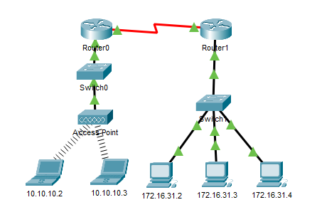

**Results Activity**

* No results activity

**Questions** 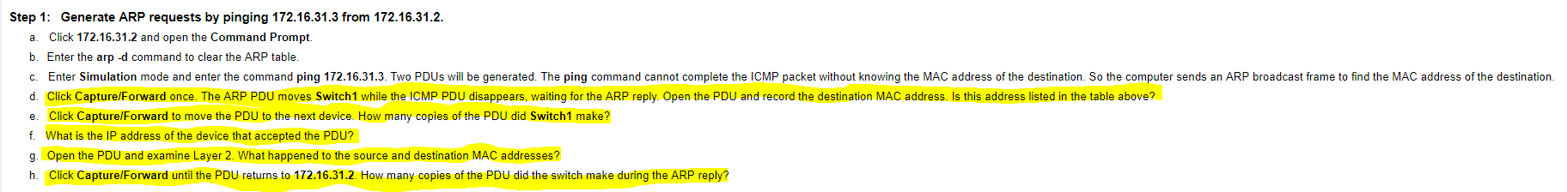

1. Click **Capture/Forward** once. The ARP PDU moves **Switch1** while the ICMP PDU disappears, waiting for the ARP reply. Open the PDU and record the destination MAC address. Is this address listed in the table above?

No

1. Click **Capture/Forward** to move the PDU to the next device. How many copies of the PDU did **Switch1** make?

3

1. What is the IP address of the device that accepted the PDU?

172.16.31.3

1. How many Serial interfaces does the router have?

2

1. Open the PDU and examine Layer 2. What happened to the source and destination MAC addresses?

Source became destination, MAC address of 172.16.31.3 replaced FFFF.FFFF.FFFF

1. Click **Capture/Forward** until the PDU returns to **172.16.31.2**. How many copies of the PDU did the switch make during the ARP reply?

1

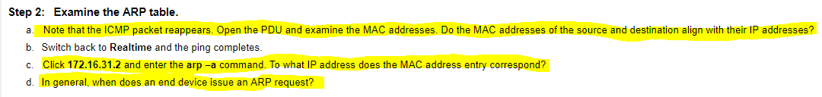

1. Note that the ICMP packet reappears. Open the PDU and examine the MAC addresses. Do the MAC addresses of the source and destination align with their IP addresses?

Yes

1. Click **172.16.31.2** and enter the **arp –a** command. To what IP address does the MAC address entry correspond?

172.16.31.3

1. In general, when does an end device issue an ARP request?

When the end device does not know the receiver’s MAC address.

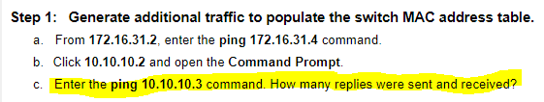

1. Enter the **ping 10.10.10.3** command. How many replies were sent and received?

4 sent and 4 received

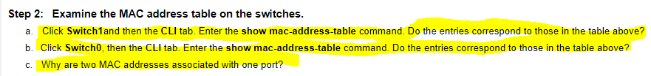

1. Click **Switch1** and then the **CLI** tab. Enter the **show mac-address-table** command. Do the entries correspond to those in the table above?

Yes

1. Click **Switch0**, then the **CLI** tab. Enter the **show mac-address-table** command. Do the entries correspond to those in the table above?

Yes

1. Why are two MAC addresses associated with one port?­

Because both devices are connected to one port through the Access Point.

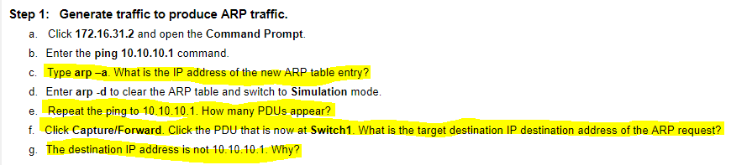

1. Type **arp –a**. What is the IP address of the new ARP table entry?

172.16.31.1

1. Repeat the ping to **10.10.10.1**. How many PDUs appear?

2

1. Click **Capture/Forward**. Click the PDU that is now at **Switch1**. What is the target destination IP destination address of the ARP request?­

172.16.31.1

1. The destination IP address is not 10.10.10.1. Why?

The gateway address of the router interface is stored in the IPv4 configuration of the hosts. If the receiving host is not on the same network, the source uses the ARP process to determine a MAC address for the router interface serving as the gateway.

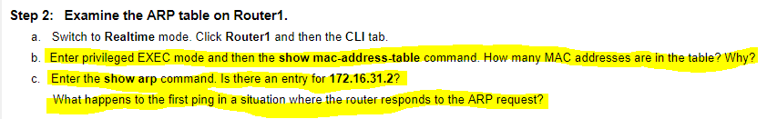

1. Enter privileged EXEC mode and then the **show mac-address-table** command. How many MAC addresses are in the table? Why?

0 because this command issued is different from entering show mac-address-table command in the switch.

1. Enter the **show arp** command. Is there an entry for **172.16.31.2**?

Yes

1. What happens to the first ping in a situation where the router responds to the ARP request?­

The ping will timeout.